Forwarded by the Chicago Chapter of the
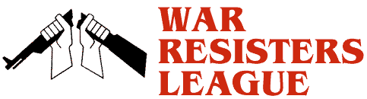

www.WRLChicago.org

Hiroshima 70th Anniversary Observance and Film, Thursday, Aug 6th in Chicago

http://icjpe.org/actions/Hiroshima-70th-Anniversary-Observance-and-Film-Aug-6-in-Chicago

Nuclear Energy Information Service
Location: Henry Moore Sculpture to Atomic Energy, between 56th and 57th Streets on S. Ellis Ave., on the University of Chicago Campus, Hyde Park, Chicago
5:30 P.M. Welcome, intro to event, moment of silence: Roberta Siegel
Thoughts, meditation: Taigen Dan Leighton, Ancient Dragon Zen Gate
Musical selections: Marian Neudel
Remarks: Dave Kraft, director, NEIS
Conclusion no later than 6:30
Walk to Logan Center; Film 7-9 PM followed by Q & A: Norma
At the conclusion of the 5:30 - 6:30 P.M. gathering on Thursday, August 6, to remember the 70th anniversary of the bombing of Hiroshima, which will take place in front of the Henry Moore sculpture on Ellis Ave. between 56th and 57th Streets, participants are invited to attend a screening of director Hitomi Kamanaka's 2003 film, Hibakusha at the End of the World. This film draws together the victims of radiation exposure from Iraq (the impact of depleted uranium from the Persian Gulf War), Hanford, WA (plutonium production, including that used for the Nagasaki bomb), and Hiroshima and Nagasaki.
Norma Field, professor emerita of East Asian Languages & Civilizations at the University of Chicago, will introduce the film and facilitate discussion. The film is 116 minutes.
The screening will be held at the Logan Center for the Arts, 915 E. 60th St. , from 7 - 9 P.M.

