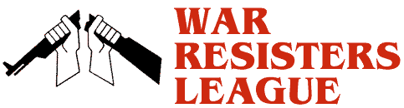
War Resisters League, Chicago Chapter
www.wrlchicago.org

Tuesday, April 18th
11-1:00 PM Federal Plaza, Dearborn + Adams
We openly refuse to pay for war. We will not wait for the U.S. government to end its wars. We will not wait for government approval of our actions. We are cutting our individual connection to war now either by refusing all those federal tax dollars that fund war, or just a portion of those tax dollars, or living below the taxable level. We invite you to join us in this public act of civil disobedience to war and war funding.
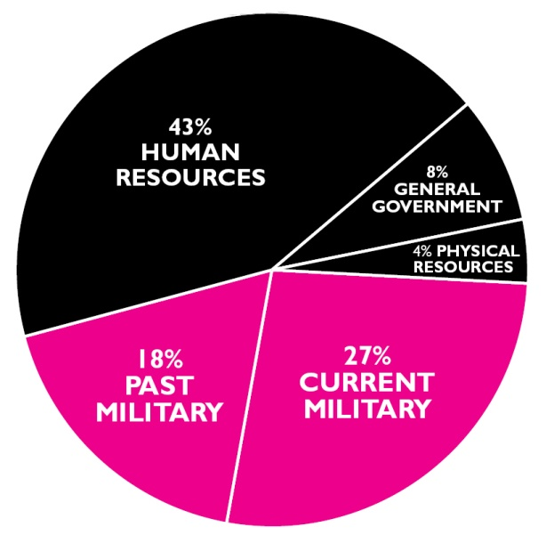

Where Your Income Tax
Money Really Goes
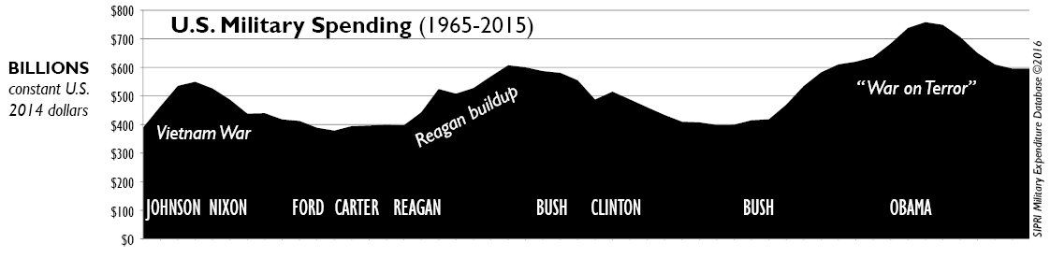
www.nwtrcc.org

