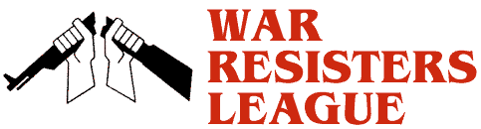
War Resisters League, Chicago Chapter
Monday, April 15th
11-1:00 PM Federal Plaza, Dearborn + Adams
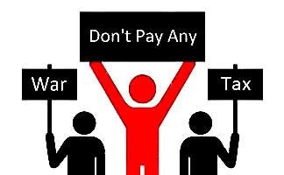
We openly refuse to pay for war. We will not wait for the U.S. government to end its wars. We will not wait for government approval of our actions. We are cutting our individual connection to war now either by refusing all those federal tax dollars that fund war, or just a portion of those tax dollars, or living below the taxable level. We invite you to join us in this public act of civil disobedience to war and war funding.
Don’t Pay War Tax Demonstration

Where Your Income Tax Money
Really Goes www.nwtrcc.org

www.wrlchicago.org

