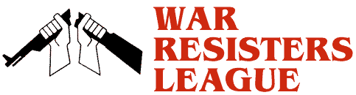

Chicago
Chapter

Program on
Saturday, October 18th
6:00 PM at the College of Complexes www.WRLChicago.org
Hilltop Restaurant
2800 W. Foster (at California) $3 Tuition

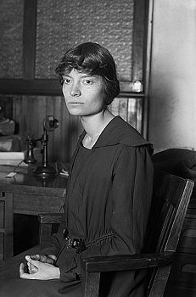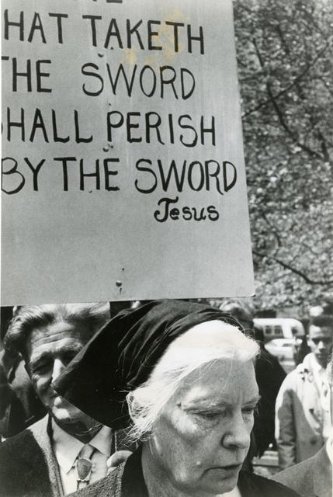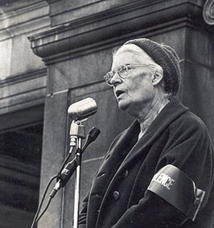
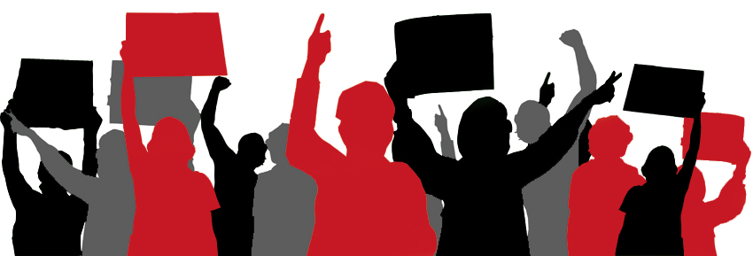
Dorothy Day, Co-Founder of the Catholic Worker Movement

Presented by Rosalie Riegle, Biographer

Overview
Dorothy Day, co-founder of the Catholic Worker, radical pacifist, friend of the poor, has been called the conscience of the American Catholic Church. Lately she has also been called a saint. But who was she, really? In this moving and entertaining work, drawn from the memories of family, friends, and colleagues who knew her best, Dorothy Day emerges as a woman of courage, humor, and love, who left an unforgettable mark on the lives of all she touched. Included here are voices -- some famous, some not -- of those who knew Day as a friend, a writer, a mother, a champion of the oppressed, a spiritual guide. They tell what it was like to march with her on picket lines, to go to jail, to pray the rosary, to discuss her favorite novels or the news of the day. At a time when Dorothy Day risks being mythologized, this collective portrait best captures her many sides: as a woman who was both ordinary and unique, who maintained her love for the opera while living in the slums, a courageous witness for peace, a devout Catholic who suffered over the sins of the church she loved, a model of holiness especially appropriate for our times.

