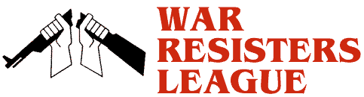

Chicago
Chapter

Wednesday, April 15th
11:00 AM to 1:00 PM
Federal Plaza, Dearborn and Adams, Chicago

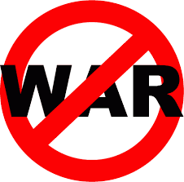
War Tax
Demonstration

We will have anti-war tax banners, the War Resisters' League's leaflet showing how federal tax money is mis-spent on the military, other leaflets with similar themes, and a sound system.
We invite you to attend and participate. For further information contact Bradford Lyttle, by phone at 773.324.0654, or by email to blyttle@igc.org
www.WRLChicago.org

